**WEB-BASED MANAGEMENT INFORMATION**

**SYSTEM WITH SMS NOTIFICATION FOR**

**CAPEDA DRIVERS OF**

**CAMELLA HOMES**

A Capstone Project

Submitted to the Faculty of

Department of Information Technology

Cavite State University

Imus City, Cavite

In partial fulfillment

of the requirements for the degree of

Bachelor of Science in Information Technology

**LUCION, MAXINE S.**

**PITOGO, SHARLYN CLAIRE S.**

**SORIANO, ERIC YEOJ H.**

January 2022

**WEB-BASED MANAGEMENT INFORMATION**

**SYSTEM WITH SMS NOTIFICATION FOR**

**CAPEDA DRIVERS OF**

**CAMELLA HOMES**

**Lucion, Maxine S.**

**Pitogo, Sharlyn Claire S.**

**Soriano, Eric Yeoj H.**

|  |
| --- |
| A capstone project outline submitted to the faculty of the Department of Information Technology, College of Engineering and Information Technology, Cavite State University, Imus City, Cavite in partial fulfilment of the requirements for the degree Bachelor of Science in Information Technology with Contribution No.______________. Prepared under the supervision of Mr. Ace Amiel E. Malicsi. |

**INTRODUCTION**

A Web-based membership system is a pivotal tool for organizations, offering an efficient means to add, store, manage, and update members' information in a centralized database. This study focuses on the development of a Web-based membership application system with integrated SMS capabilities to streamline and modernize the membership management process.

CAPEDA has a rich history dating back to 1986 when it was founded by Pablo Guerrero. Comprising pedicab drivers, CAPEDA has played a vital role in providing daily transportation services to the residents of various areas in Camella Bacoor. Over the years, the pedicab, originally a manually operated "padyak," has evolved into electric-powered bikes, known as E-bikes. In the present year, CAPEDA boasts a membership of 500 individuals, with the majority having transitioned to E-bikes as the primary source of power for their pedicabs.

Pedicabs stand out as a financially and environmentally friendly mode of transportation, positioning themselves as a viable alternative to traditional, smoke-emitting vehicles in terms of mobility. They are a common sight in Philippine cities and local areas. As pedicabs gain popularity among commuters, more Filipinos with basic driving skills are drawn to this occupation as a means of making a living.

As the population of pedicab drivers within CAPEDA continues to expand, the membership application process and the collection and preservation of member data have become increasingly arduous. The organization's current membership procedure demands a substantial investment of time and effort, affecting both CAPEDA officers and prospective members alike. Moreover, their data recording relies heavily on manual transcription into Microsoft Word documents for each member. This not only hampers efficiency but also exposes the organization to inefficiencies such as data loss, security threats, and potential data breaches.

Recognizing these challenges, this research endeavors to provide a solution by developing a Web-based Membership Application System. The primary goal is to enhance CAPEDA’s membership application process, data collection and management process, ensuring a more convenient and streamlined experience for both the organization's staff and its members. This system aims to usher CAPEDA into the digital age, eliminating the dependence on manual record-keeping, reducing errors, and improving the overall efficiency of managing their growing membership.

**Project Context**

CAPEDA, an acronym for the Camella Homes II Pedicab Drivers Association, was established in 1986 under the leadership of Pablo Guerrero. Initially conceived as a collective of padyak drivers serving the transportation needs of multiple barangays within Camella, Bacoor, the organization has evolved significantly over the years. Originally providing daily transportation for residents using manually powered bicycles capable of accommodating three to four passengers, the advent of electric-powered bicycles presented an opportunity for innovation among CAPEDA drivers.

Presently, CAPEDA boasts a roster of five hundred registered drivers. However, the substantial growth in membership has posed challenges for the organization's auditor in effectively managing and organizing pertinent information. Regrettably, the auditor, lacking technical expertise, relies on manual methods using a personal desktop and Microsoft Word to maintain records. This outdated approach significantly hampers their efficiency, as manually inputting personal details of both existing members and new applicants is a time-consuming process. Such practices are inevitably leading to a mounting workload that may impede their ability to manage and retrieve information swiftly.

Storing vast amounts of data locally on their computer has caused a slowdown in performance, making searches and modifications to records increasingly burdensome. The inherent risks of data loss or unforeseen errors due to these antiquated processes pose a significant threat to the integrity of the organization's records. It is imperative for CAPEDA to modernize its information management systems to ensure the security and accessibility of their data and prevent potential setbacks in their operations.

**Objectives of the Project**

Generally, this study aims to design and develop a web-based management information system for CAPEDA Association.

It specifically aims to:

1.    Plan the desired system by discussing how the current information management works, outline the requirements, brainstorm a feasible alternative, consider the modules and components needed, as well as their usage;

2.   Design a web-based system that will replace the manual process of managing membership applications. In this phase, the proponents will present a flowchart with the objective of gathering feedback from the client;

3.   Develop the system using the propositions approved by the client.

4.   Test the developed system by evaluating and assessing it for possible bugs and logic errors. This phase requires a lot of time as it is the stage wherein both the proponents and the client would have to communicate and analyze the system thoroughly;

5. Deploy the system to the end users. In this phase, the system will be accessible to both applicants and existing members of CAPEDA.; and

6. Maintain the deployed system continuously when adjustments or updates are necessary.

**Purpose and Description**

The study was conducted to know the needs of the organization to improve the membership application process for the CAPEDA. The researcher developed a web-based system that will aid the organization’s needs to provide a convenient and accessible platform for the members and organize the application processes. This project has helped the CAPEDA to increase efficiency and accuracy in handling data, and have an easier and faster way of managing the organization; this system has benefitted both the client and the users.

The web-based management information system has the following capabilities:

1. Online membership registration, potential drivers can apply for membership online, they can create their own profile or go to the auditor’s office for assistance.
2. The system facilitates the comprehensive management of applicants, members, and pedicab units. Administrators possess the capability to oversee and manage lists of members, applicants, and pedicab units. This includes the ability to monitor active and inactive members, approved and denied applicants. Moreover, administrators can track individual pedicab units and ascertain the designated drivers for each unit.
3. The system has an announcement notification through SMS or email. When officers set a meeting or event members will either receive notifications on their accounts and emails to be informed. This notification also provides instructions on what the drivers should do, what is the announcement about, where and when will the set event will occur.
4. The system is equipped to store digital copies of essential documents, including scanned Barangay clearances, NBI clearances, and other necessary paperwork for membership applications. This feature ensures the safety and accessibility of these documents for future retrieval, eliminating the need for physical storage space.

Once the web-based management information system is implemented, it will give the following significance particularly to the following:

1. **Camella Bacoor Pedicab Drivers Association (CAPEDA)** – With the proposed Web Based Information Management System. it will help the association to organize and manage the members and applicant’s information that will be submitted to them. In the future, if CAPEDA decided to fully implement and acquire this Web Based Information Management System, it will be a great help for the organization because it will offer solution to the problems that they acquire and it will be easier for them to manage, modify, verify, and store information.
2. **CAPEDA members –** This project will help them keep track of their information because having a systematic and structured system will help to reduce the possible work they had to exert to apply modifications on their personal information. It will also let them be notified about news and announcements such as meetings through SMS.
3. **CAPEDA Applicants** – This project will help them in terms of application process because it will be easier for them to check and submit the requirements needed for a CAPEDA membership.
4. **CAPEDA Officers** – This project will help them in terms of verification process because it will be easier for them to validate and approve the documents and application that were submitted by the applicants. It will also aid the officers in terms of Information Management because the members’ information will be stored in a database wherein they could be easily accessed for viewing and modification.
5. **Students** – This project will help them in terms of communicating with their thesis adviser, technical critic, and Unit Research Coordinator. This project can be used by the students as a medium for passing their thesis or capstone project, and facilitate their needs so that it will be easier for them to look for resources through student outputs like capstone projects and thesis that they can use for their own research projects.
6. **Researchers** – This project will help them to expand their knowledge about designing and building a system that will help manage, store, modify and verify applicant’s and member’s information of the CAPEDA. In addition, the researchers were able to discern the problems met by the existing CAPEDA members, admin, and applicants and apply the right technology and management principles that would resolve the current unsatisfactory conditions. Furthermore, it will strengthen their comprehension about how they should conduct research about a web-based management information system and what things to consider when planning a system.
7. **Future researchers** – This study will give them sufficient information in planning and constructing a Web-based Information Management system. In the future, the findings and conclusions of this project will be significant and help them if they decide to choose the same topic for their future research.

**Conceptual Framework**

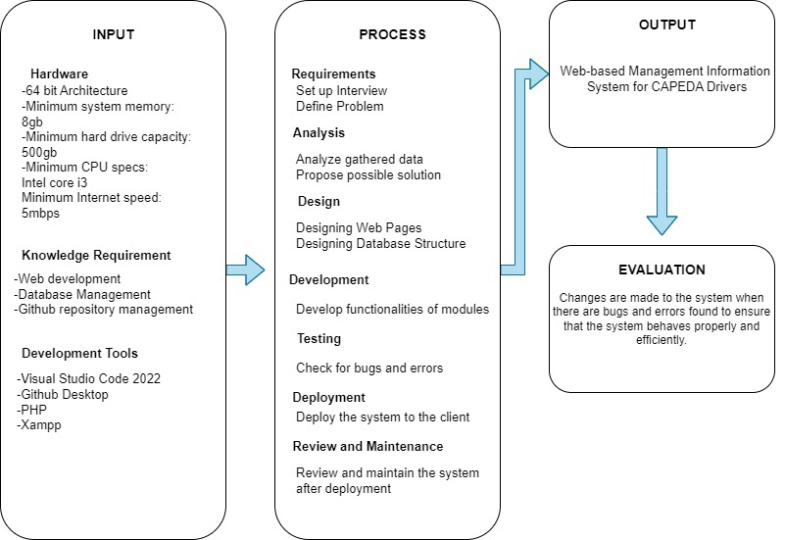

Figure 1.Conceptual framework

Figure 1 represents the conceptual framework of the project, it consists of the input, process, and output elements that completes the system

**Scope and Limitation of the Study**

This study aimed to construct a better way of managing CAPEDA members and applicant’s information. This web-based membership system allows its affiliates to manage their membership and registration process digitally. The system will have three user types: Applicant, Member, and Admin. The Applicant account can be accessed by users that aren’t registered as a pedicab driver under CAPEDA. The Member account can only be accessed by users that are registered under CAPEDA. The Admin account can only be accessed by the organizations’ officers.

The following are the modules of the system along with its feature:

**Account Modules:**

User Authentication: This pivotal module is responsible for validating user accounts attempting to access the system. The system accommodates three distinct user types, each with varying levels of authorization. Firstly, the "Applicant" is the entry-level user type, granted access to limited features. Next, the "Members" category includes individuals who have successfully passed the screening process and received approval from the organization's officers or administrators. Lastly, "Admins" possess the highest authority, enabling them to manage critical information related to both members and applicants.

Registration: The system offers two modes of account registration, catering to different user preferences and needs. The first method is "User-Generated Registration," allowing applicants to create their own accounts and initiate the verification process. However, simply verifying their email does not guarantee immediate access to the system. Upon email verification, administrators will review and either approve or deny the application. Approved applicants gain access to the applicant dashboard, where they can upload the required documents for membership. In contrast, denied applications receive notifications about the status of their submission. The second registration method is "Admin-Generated Accounts," designed for applicants who may not be proficient in using computers. Administrators generate accounts on their behalf, including email verification, and oversee the application process. Admin-generated accounts are assigned temporary passwords, which are provided to the applicants for future access to their accounts.

**Member-Related Modules:**

Applicant Module – This module is designed exclusively for users who meet the eligibility criteria for membership application. Within this module, eligible applicants have the opportunity to upload the requisite documents as specified by the organization's officers. Once the applicants have successfully uploaded their required documentation, administrators will conduct a comprehensive review to ensure the completeness and validity of the submitted materials.

Upon verification and confirmation that all necessary documents are in order, the administrators will facilitate the next steps in the membership application process. This typically includes scheduling an appointment for the applicants to visit the organization's premises in person, where they can finalize their membership and process the associated membership fees.

Member Module – this module will be accessible only for the members of the CAPEDA, in this module they can edit their personal information with restrictions, change their password, and upload documents if the officers request some.

**Admin-Related Modules:**

1. Admin Module – is exclusively accessible to the officers of CAPEDA, granting them comprehensive control over the organization's digital operations. This module has a range of pivotal functionalities designed to streamline and enhance administrative tasks such as managing the registered members and their personal information, managing the applications, and the creation of news and announcements. Using Account Creation, creating user accounts for applicants, particularly for those individuals who may not be proficient in digital processes is possible, ensuring that no eligible candidate is excluded from the membership application process. The Member Management can efficiently monitor and manage the growing roster of CAPEDA members. It includes overseeing their profiles, ensuring data accuracy, and addressing member-specific needs. The Requirements Management module has the capacity to dynamically manage the list of required documents, enabling them to add, modify, or update the essential documentation necessary for the application and membership process. The Announcement Creation is where craft, update, and announcements to the CAPEDA community comes from, ensuring that all members and applicants stay informed about essential organizational news, events, and alerts. The Document Monitoring provides a critical overview of all uploaded documents, both from applicants and members. Using this module, viewing, downloading, and evaluating documents to facilitate the application and membership verification process is possible.

The modules in each category are related by their functions and the roles they serve in the web-based membership application system. The "User Authentication Module" deals with user login and access control. The "Member-Related Modules'' are focused on tasks and features available to CAPEDA members. The "Admin-Related Modules'' are designed for administrators to manage applicants, members, requirements, announcements, and document submissions.

While the system developed by the proponents offers significant advantages, it also has certain limitations:

The limitations of the system are that it is not accessible offline, the web-based system will run only if there’s an internet connection. Also, the billing process of the membership application is out of the scope of this research.

**Definition of Terms**

To understand the study, the below terms are operationally defined:

**Admin-Related Modules:** Specific system functionalities designated for administrators, including managing applicant registrations, membership verifications, and document monitoring.

**Billing Process:** The monetary transactions associated with membership applications, which falls outside the scope of this particular research and system development.

**CAPEDA:** Camella Homes II Pedicab Drivers Association: An acronym for the organization CAPEDA, which was founded in 1986 by Pablo Guerrero to provide transportation services using pedal-operated and subsequently electric-powered pedicabs in the Camella Homes area.

**E-bikes**: Electric-powered bicycles utilized by CAPEDA drivers as an alternative mode of transportation.

**Input, Process, and Output Elements**: Components integral to the conceptual framework of the developed system. Inputs represent data or commands, processes denote system operations, and outputs depict results or information generated by the system.

**Member-Related Modules:** System modules dedicated to functions available to CAPEDA members, such as personal information management, document uploads, and profile modifications.

**Offline Accessibility Limitation**: The constraint indicating the system's reliance on an internet connection for operation.

**Organization’s Officers/Administrators**: Responsible individuals within CAPEDA involved in managing and overseeing membership processes, applicants, and pedicab units.

**SMS Notification:** Short Message Service notification, a means of communication through text messages delivered to CAPEDA members, applicants, and administrators to disseminate information about meetings, events, and other relevant announcements.

**System Deployment:** The process of making the developed web-based system accessible and operational for use by CAPEDA members and applicants.

**User Authentication Module:** System functionality responsible for verifying and granting access to different user types (Applicants, Members, and Admins), ensuring appropriate access control.

**Web-based Management Information System (MIS):** A digital platform accessible through web browsers, designed for organizing, managing, and updating information, particularly in the context of CAPEDA (Camella Homes II Pedicab Drivers Association) operations.

.**REVIEW OF RELATED LITERATURE AND STUDIES**

This chapter presents the review of related literature and studies underlying the framework of the study.

**Technical Background**

I will not provide a sample technical background here as it depends on your technology to use. I will just leave a sample RRLS which was already in the next section. Just give a good review of your materials. In developing this background, however, must be the same as the RRLS – just like a review with citation. The only difference is that technical background focuses on the description of the technology while the RRLS focuses on the applications which used that technology and its impact.

My sample RRLS is about barcode technology. So to write its technical background, we can describe the barcode technology entirely – what it is, how it works, etc.

**Review of Related Literature**

**BookNow Software. (2023) *Key Benefits of Member Management Software*.**

                  According to an article for BookNow Software, having a member management system produce positive impacts for the business and its components. By having a software that will help with the management of data and information, businesses are more likely to perform better. It also attracts potential customers/members because it enables transparency by making sure members are able to see every detail they need to see. Also, this type of softwares provides peace of mind in exploring new ways of improving businesses. BookNow Software (2023).

**Davies Genealogy. (2019) *Advantages of Online Applications*.**

As indicated by an article published by Davies Genealogy, it is vital to understand that online applications are helping various organizations to accumulate qualified applicants and enhancing the overall candidate experience. Physically applying for a job can be time consuming and expensive, however, you have an opportunity to reduce all that by using online application platforms.

**Review of Related Studies**

**Umrah Registration System Using Extreme Programming Method Towards Worship Tourism. *International Journal of Cyber and IT Service Management*, *3*(1), 22–31.**

    A study conducted in 2022 paved the way for enhanced method of handling registration applications by developing a Registration System that helped with the daily transactions and handling of big amounts of data. It was also shown that having such a system helped the business to store big amounts of data, it also helped with the time consumption regarding the transaction processes of the business. usanto, U., Nurlaela, L., Sopian, A., & Alfiah, F. (2022).

**Learning Management System Adoption in Higher Education Using the Extended Technology Acceptance Model. *De La Salle-College of Saint Benilde Manila Philippines.***

   According to Marissa Fearnley and Johnny Amora (2020). This study investigated factors that influence adoption of a learning management system by higher education teachers using the technology acceptance model which incorporates three external constructs: system quality, perceived self-efficacy and facilitating conditions. Additionally, system quality directly affected perceived ease of use and attitudes toward technology use. Implications for practice, policy and potential research directions are likewise presented.

**Synthesis**

You have to put your justification that your capstone project is really different from your cited materials. Convince the readers that your research still has gaps from others in terms of methodology, technology, among others even if the nature of the studies is similar.

**METHODOLOGY**

This chapter presents the materials, methods, and data gathering techniques, data analysis, and implementation plan.

**Requirement Analysis**

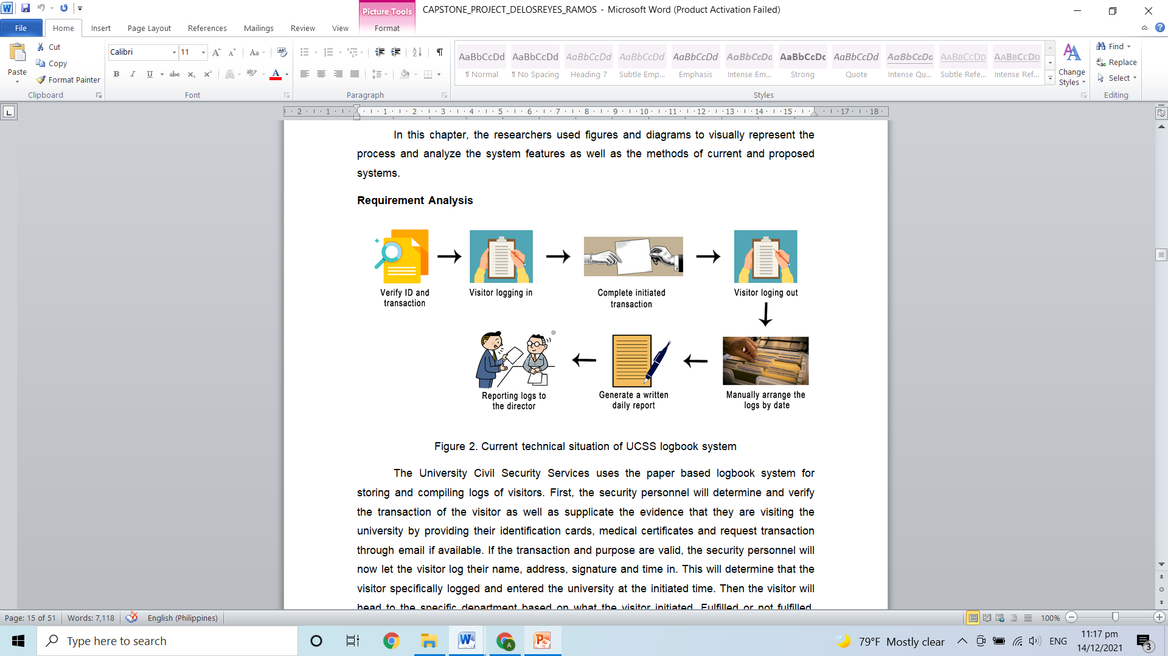

Figure 3.Current technical situation

Edcar Manpowers Services manages the salary of their employees through time card and manually computing their salary. After computing the salary, they also manually deduct benefits like SSS and PAG-IBIG. Then the secretary submits the payroll to the company. Employees can see their salary by going to the company. The reports of contribution on benefits are then submitted to their respective offices.

**Requirement Documentation**

Based on the interview conducted with the client, the following features have been agreed:

Table 1. Features of the proposed system

|  |  |
| --- | --- |
| **Main Features** | **Detailed Features** |
| Sell configured products | 1. The e-commerce system shall display all the products that can be configured. 2. The e-commerce system shall allow the user to select the product to configure. |
| Provide comprehensive product details | 1. The e-commerce system shall display detailed information of the selected products. 2. The e-commerce system shall provide browsing options to see product details. |
| Provide search feature | 1. The e-commerce system shall enable user to enter the search text on the screen. 2. The e-commerce system shall display all the matching products based on the search. 3. The e-commerce system shall display only 10 matching result on the current screen |
| Maintain customer profile | 1. The system shall allow user to create profile and set his credential. |
| Email confirmation | 1. The system shall send an order confirmation to the user through email. |
| Provide invoice for customer | 1. The system shall display detailed invoice for current order once it is confirmed. |
| Provide shopping cart | 1. The e-commerce system shall provide shopping cart during online purchase. 2. The e-commerce system shall allow user to add/remove products in the shopping cart. |

The following table, however, presents the non-functional requirements of the proposed system:

Table 2. Non-functional requirements of the system

| **QUALITY ATTRIBUTES** | **DESCRIPTION** |
| --- | --- |
| Time Behavior | The system must load within 5 seconds |
| Usability | The e-commerce system shall provide a uniform look and feel between all the web pages. |
| Accessibility | The e-commerce system shall provide multilingual support.  The e-commerce system shall be accessible by people who are color blind |
| Security | The e-commerce system shall automatically log out all customers after a period of inactivity.  The e-commerce system’s back-end databases shall be encrypted. |
| Scalability | The website attendance limit must be scalable enough to support 200,000 users at a time. |
| Compliance | The system must meet Web Content Accessibility Guidelines WCAG 2.1. |

**Software Design**

This is just a sample: After the purpose and specifications of the application are determined, the researchers will design or employ a plan for the computing solution. This includes low-level component and algorithm implementation issues as well as the architectural view.

In this stage, the preparation of the logical design, the physical design, and the user interface design will be carried out. There is also the functional and non-functional requirements which will be transformed into diagrams and charts.

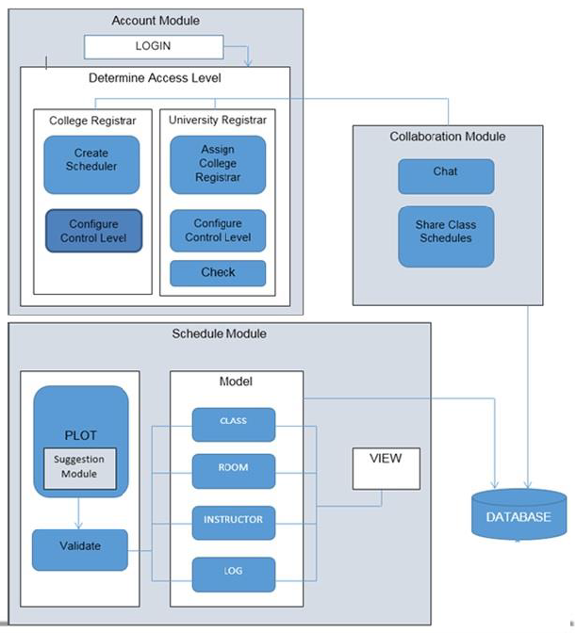

Figure 2. System architecture

The system architecture, presented in Figure 2, is composed of different modules:

**Account module.** This module utilizes an employee management that makes adding, editing, and deleting of employee information. The system also shows details of the employee such as ‘active’ and ‘inactive’, among others.

**Payroll module.** This module will create a reliable and accurate payroll system that will generate reports based on different primary keys such as employee, dates, etc. the report may include the following at the options of the users: SSS contributions, PhilHealth, Union dues, PAGIBIG, loan payment, among others.

**File Archive Mode.** This module will provide a data file archive that allows backing up of files and data records that can be exported from the database.

The architecture is divided into two (2) parts: the online and offline versions. The proposed application will accept user inputs through the use of microphone for accepting speech input; accelerometer device for the jumbling of letters to see them in a different way; and touch screen for the navigation through the game. For accepting speech inputs, the Google Speech API will be utilized for the online version while the offline version makes use of Pocketsphinx, an open-source library recognition. The audio and video cards are used for the output processes aided by the ADT plugin.

The random picking of words from the database will be done by the Fisher-Yates algorithm because the application requires different set of words every game session without repetition.

**Development and Testing**

The computer unit to be used in developing the mobile application will have the following hardware and software specification: Microsoft Windows 10 Education 64-bit operating system, 8GB DDR4 RAM, Intel Core i7-7500U CPU@ 2.7 GHz, 2904 MHz, 2-core, 4 logical processor with 6GB Intel HD Graphics and 2GB NVIDIA GeForce 920m x64-based processor. The researchers will use Construct 2 for developing the mobile application, Adobe Photoshop CS6 for graphic design, SQLite for database system, and Microsoft Word 2016 for documentation.

In the development of the software, the researchers will use Doppler Interactive Game Development Life Cycle as their guide in developing the software which is composed of six (6) phases: design, develop/redevelop, evaluate, test, review, and release (see Figure 2).

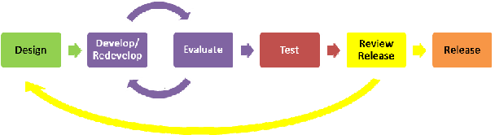

Figure 4. Doppler interactive game development life cycle (McGrath, 2011)

For the discussion, just put your chosen software development life cycle then discuss each phase on how you will take that during the development of your software/capstone project. Do not copy paste the description of the phases based on your source/s. You need to put your own description because you, as researchers, must know what and how to do your software.

For the testing part, please discuss how you will perform unit, integration, and system testing. Also, discuss the software quality standards that you will use – ISO 9126 or ISO 25010. Discuss its characteristics and how you will perform the tests.

**Data Analysis Plan**

Here is a sample of data analysis plan. This covers sampling method, instrumentation, and statistical treatment of data.

The researchers will choose the Grade 12 students and biology teachers from CvSU Science High School as their estimated population. It is because based on their academic curriculum, they are currently taking a biology subject which includes topics regarding cells. Within the population, the researchers will pick 55 students and 2 teachers as their respondents that will answer the interview questionnaire provided by the researchers. The researchers will use convenience sampling technique in choosing their respondents. Convenience sampling is a type of sampling where the first available primary data source will be used for the research without additional requirements. In other words, this sampling technique involves getting participants wherever you can find them and typically wherever is convenient. The overall simplicity and ease of research makes it more accessible for researchers (Gall, Borg, & Gall, 1996).

Survey questionnaires will be used by the researchers to answer the problems encountered by the chosen organization. The respondents will be instructed to answer the questions appropriately and to provide thorough responses. The researchers will provide spaces for the students to provide their names and signatures. It is optional for the respondents if they want to provide their names or not. The first part of the questionnaire contains three questions that corresponds to the understanding on certain topics, teaching approaches or methods used by the teachers, and how static instructional materials contributes to the overall explanation of the concepts. The second part has four questions that deal with the use of microscopes - its accessibility, specifications, and the availability of other equipment that could be used in observing cells. Lastly, the third part of the questionnaire talks about the approaches used by the teachers to gain the attention of the students, the students’ overall interest regarding the topic, and the factors that causes the students to lose attention.

The researchers will use pointing system to acquire the level of agreement of the respondents on the questions in the survey questionnaire. The points to be used are:

**Table 1.** Options in each item of the questionnaire

|  |  |
| --- | --- |
| **SCORE** | **INTERPRETATION** |
| 5 | Excellent |
| 4 | Very Good |
| 3 | Good |
| 2 | Fair |
| 1 | Poor |

Table 2 shows the Likert scale that can be used to generate the overall interpretation of the mean score of each item.

**Table 2.** Likert scale

|  |  |
| --- | --- |
| **RANGE OF WEIGHTED MEAN** | **INTERPRETATION** |
| 4.51 - 5.00 | Excellent |
| 3.51 - 4.50 | Very Good |
| 2.51 - 3.50 | Good |
| 1.51 – 2.50 | Fair |
| 1.50 and below | Poor |

On the other hand, the following statistical procedures will be used to analyze the data to be gathered from System Evaluation Questionnaire. The results of the statistical procedure will determine the general perception of the respondent on the system.

Sample mean is the average score of a sample on a given variable.

Formula:

$$\overline{x}=\frac{\sum_{i=1}^{n}{X_{i}}}{n}$$

Where:

$\overline{x}$ = mean

$X_{i}$ = representation of each observation from respondents

$n$ = total number of respondents

Sample standard deviation is a measure of the spread (variability) of the scores in the sample on a given variable.

Formula:

$$s=\sqrt{\frac{\sum_{i=1}^{n}{{(X_{i}-x̅)}^{2}}}{n-1}}$$

Where:

$\overline{x}$ = mean

$X_{i}$ = representation of each observation from respondents

$n$ = number of respondents

$s$ = sample standard deviation

Percentage determines the frequency counts and percentage distribution of personal related variables of the respondents.

Formula:

$$\%= \frac{f}{n}×100$$

Where:

% = percentage

f = frequency

n = total number of respondents

**Implementation Plan**

Here’s a sample discussion of an implementation plan:

The developed system will be sent to MinSCAT immediately after the revision to present it once more to the expected users. If the institution wants to adopt the system, the researchers will hand over the system together with its documentation. It will serve as a guide to the administrator who will be assigned for the system’s update and maintenance. There would be a letter of agreement that the system will be handed over to the institution freely and the researchers is no longer responsible for its update and maintenance. If the system will be implemented, the researchers will conduct several strategies. Those strategies are presented below.

Table 1.Implementation plan

|  |  |  |  |
| --- | --- | --- | --- |
| **STRATEGY** | **ACTIVITIES** | **PERSONS INVOLVED** | **DURATION** |
| Sample strategy | Sample activity | Sample person | Sample schedule |
| Sample strategy | Sample activity | Sample person | Sample schedule |
|  |  |  |  |
| Sample strategy | Sample activity | Sample person | Sample schedule |

You must know how to implement your software to the organization. So you have to formulate your own plan to implement the software.

**REFERENCES**

1

2

3

Demong, R., Abu Hassan, L.F., Besar, T.B., & Zulkifli, Z. (2009). *Electronic document*

*tracking system (EDTS): A prototype*. Malaysia: UniversityTeknologi MARA

Department of Public Works and Highways (DPWH). (2011). *Implementation of the*

*document tracking system (DoTS) for civil works projects*. Retrieved from

https://www.dpwh.gov.ph/dpwh/issuances/department-order/3406

Kumar, V., Barwal, P.N., & Murthy (2015). *File tracking system*. International Journal

of Scientific Engineering and Applied Science (IJSEAS), 1-2. ISSN: 2395

-3470

Neese, J. & Snodgrass, K. (2003). *Assembling a bar-code tracking system*. USA:

United States Department of Agriculture